Each website has different customization needs. Depending on what you want to do with your website, you will come across new questions.

For example how to [add a contact form](https://www.wpbeginner.com/beginners-guide/how-to-create-a-contact-form-in-wordpress/), or create [separate page for blog posts](https://www.wpbeginner.com/wp-tutorials/how-to-create-a-separate-page-for-blog-posts-in-wordpress/).

We recommend browsing through our [WordPress Tutorials](https://www.wpbeginner.com/category/wp-tutorials/) section which has **500+** step by step tutorials for beginners.

You can also subscribe to WPBeginner’s [YouTube Channel](http://www.youtube.com/wpbeginner) for free WordPress video tutorials.

#### **Continue Learning WordPress**

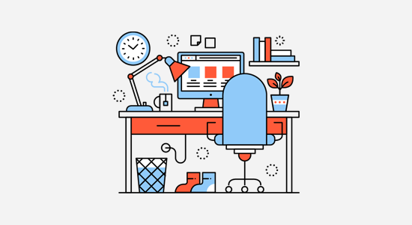

Hopefully, by the end of the week, you have been able to set up your website and familiarize yourself with how WordPress works.

However, WordPress is an incredibly powerful platform, and you’ll keep discovering new things as you work on your website.

The following are a few tips to help you continue learning WordPress.

As you come across a problem, you can search for it using the Search feature on our website.

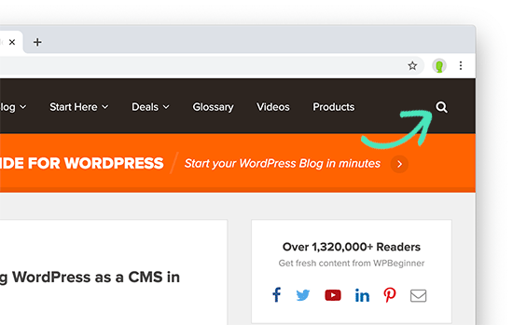

Alternatively, you can simply enter your question in Google and add WPBeginner at the end of your search query to find the most helpful answer.

As the largest WordPress resource site in the world, there is a good chance that you’ll find a step-by-step guide written specifically for beginners.

Can’t find an answer? Join our [WPBeginner Engage](https://www.facebook.com/groups/wpbeginner/) Facebook group. It is an online community of WPBeginner users with more than 69,000 members. Our team of experts and other industry veterans are actively helping out users there (for free), and you’ll also get advice from other WordPress users as well.

**How do I start learning WordPress development?**

Many of our beginner users often graduate to intermediate and advanced level users. They ask us for guidance on learning how to code their own solutions.

WordPress is mainly written in the [PHP programming language](https://www.wpbeginner.com/glossary/php/) along with HTML, [CSS](https://www.wpbeginner.com/glossary/css/), and JavaScript. We recommend starting with HTML and CSS and then move on to PHP and [JavaScript](https://www.wpbeginner.com/glossary/javascript/).

Once you have learned a good bit of these languages, you can start learning how to code your own plugins and [custom WordPress themes](https://www.wpbeginner.com/wp-themes/how-to-easily-create-a-custom-wordpress-theme/) from scratch.

You can learn all these things for free using Google and free resources available. However, there are websites offering professional training courses in different WordPress development areas.

We hope this article helped you learn WordPress in a week. You may also want to see our guide on [how to increase your website traffic](https://www.wpbeginner.com/beginners-guide/how-to-increase-your-blog-traffic/), [how to create an email newsletter](https://www.wpbeginner.com/beginners-guide/how-to-create-an-email-newsletter/), and [how to speed up your WordPress site](https://www.wpbeginner.com/wordpress-performance-speed/).

If you liked this article, then please subscribe to our [YouTube Channel](http://youtube.com/wpbeginner) for WordPress video tutorials. You can also find us on [Twitter](http://twitter.com/wpbeginner) and [Google+](https://plus.google.com/101634180904808003404/posts)